**BUSINESS ANALYSIS**

**Steps In Data Analysis Project:**

* Ask - Create a problem Statement.
* Prepare - Identify the data you want to analyse.
* Process - Explore and Clean the data.
* Analyse - Analyse the data to get useful insights.
* Share - Present the data in terms of reports or dashboards using visualization.

**Problem:**

In recent years, City Hotel and Resort Hotel have seen high cancellation rates. Each hotel is now dealing with several issues as a result, including fewer revenues and less than ideal hotel room use. Consequently, lowering cancellation rates is both hotels' primary goal to increase their efficiency in generating revenue, and for us to offer thorough business advice to address this problem.

NOTE:

The analysis of hotel booking cancellations as well as other factors that have no bearing on their business and yearly revenue generation are the main topics of this report. And the data set is taken from Kaggle. Data set name: (hotel bookings).

Assumptions:

1. No unusual occurrences between 2015 and 2017 will have a substantial impact on the data used.

2. The information is still current and can be used to analyse a hotel's possible plans in an efficient manner.

3. There are no unanticipated negatives to the hotel employing any advised technique.

4. The hotels are not currently using any of the suggested solutions.

5. The biggest factor affecting the effectiveness of earning income is booking cancellations.

6. Cancellations result in vacant rooms for the booked length of time.

7. Clients make hotel reservations the same year they make cancellations.

Research Question:

1. What are the variables that affect hotel reservation cancellations?

2. How can we make hotel reservations cancellations better?

3. How will hotels be assisted in making pricing and promotional decisions?

Hypothesis:

1. More cancellations occur when prices are higher.

2. When there is a longer waiting list, customers tend to cancel more frequently.

3. Most clients are coming from offline travel agents to make their reservations.

**Analysis and Observation:**

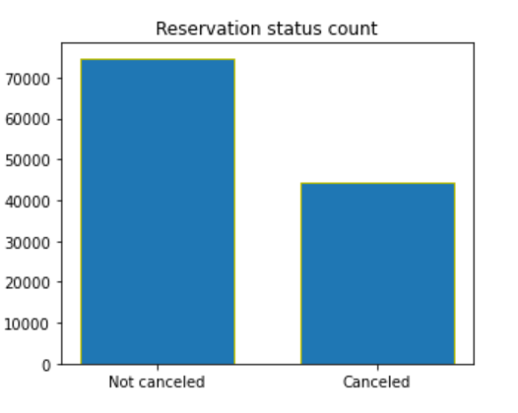

The graph shows how many reservations have been cancelled and how many have not. It's clear that a lot of reservations haven't been cancelled yet. There are still about 37% of clients who have cancelled their reservations, which means that the hotels' earnings are affected.

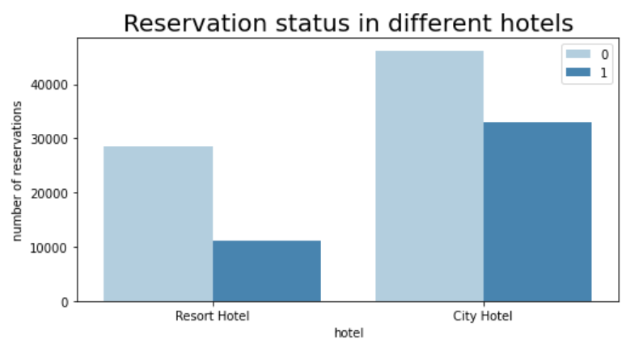

City hotels tend to be booked more than resort hotels, which may be because they're a bit more expensive.

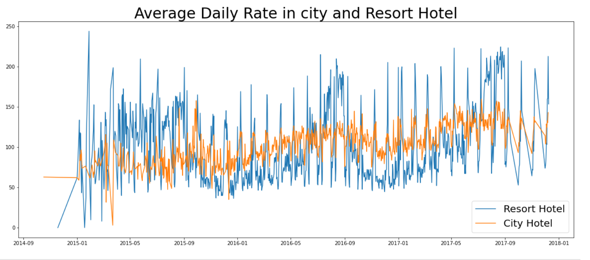

The graph shows that on some days, the average hotel rate for a city is less than that of a resort hotel. But on other days, the hotel rates are even lower. This is obviously true during weekends and holidays.

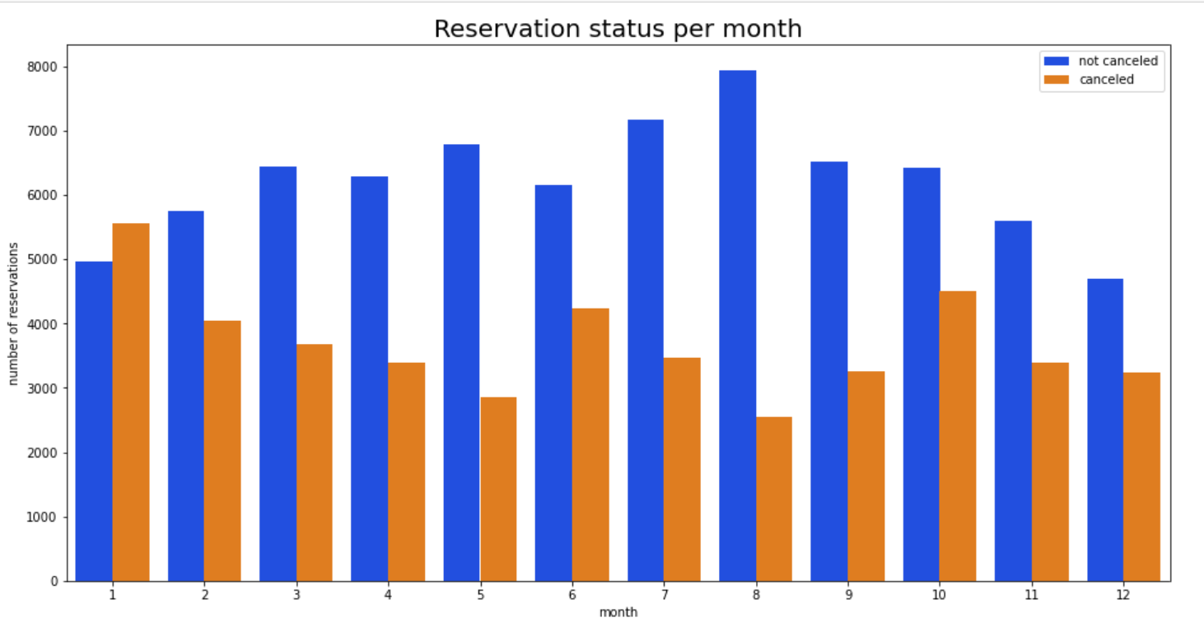

The graph shows how many reservations there are each month, broken down by whether the reservation was confirmed. In August, there are a lot of confirmed reservations, and in January, a lot of reservations are cancelled.

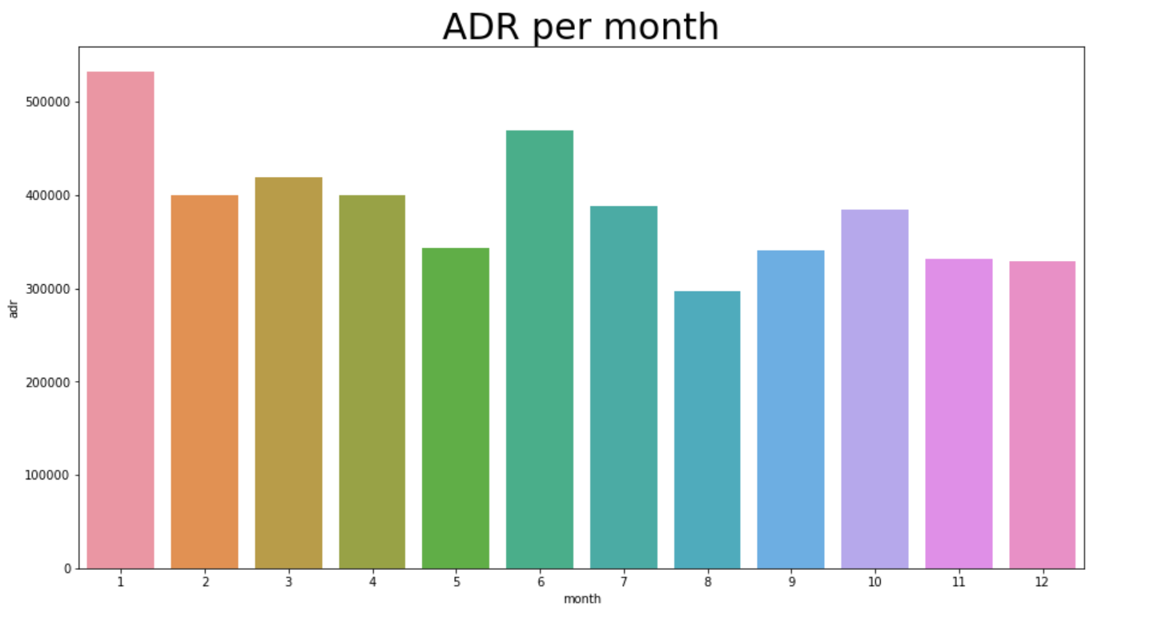

This graph shows that most cancellations happen when the price of the accommodation is highest. And the least number of cancellations happen when the price of the accommodation is lowest. So the cost of the accommodation is mainly responsible for the number of cancellations. Let us see which country has the most cancelled reservations. The country with the most cancelled reservations is Portugal.

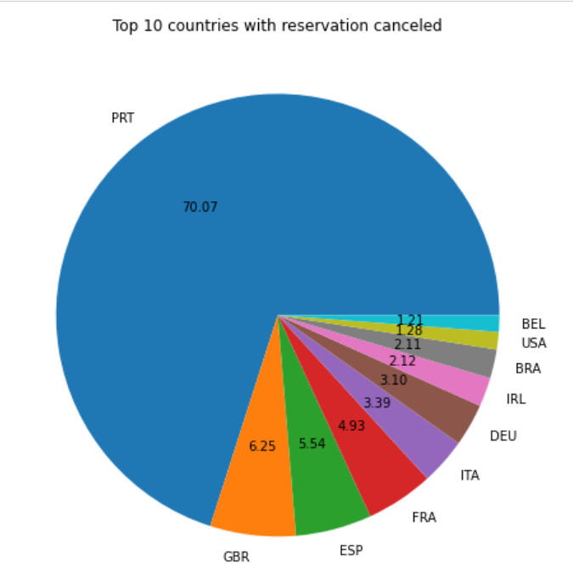

Most people who visit hotels make reservations through online travel agencies (46%), while 27% come from groups. Around 4% of people book hotels directly from where they are living.

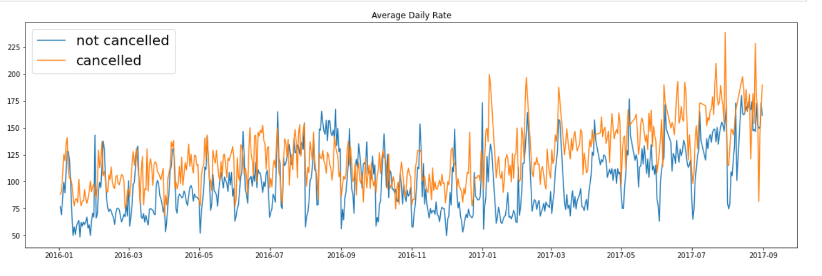

When the average price is higher than when it isn't, reservations are cancelled. This proves that when the price is high, more people decide to cancel their reservations.

Suggestions:

1. Cancellation rates rise as the price does. In order to prevent cancellations of reservations, hotels could work on their pricing strategies and try to lower the rates for specific hotels based on locations. They can also provide some discounts to the consumers.

2. As the ratio of the cancellation and not cancellation of the resort hotel is higher in the resort hotel than the city hotels. So the hotels should provide a reasonable discount on the room prices on weekends or on holidays.

3. In the month of January, hotels can start campaigns or marketing with a reasonable amount to increase their revenue as the cancellation is the highest in this month.

4. They can also increase the quality of their hotels and their services mainly in Portugal to reduce the cancellation rate.